Edu Tutor AI
Generative AI with IBM
Introduction
• Team Member: Geetha M
• Team Member: Kamali Sri M
• Team Member: Janapriya M
• Team Member: Kavya M
Project Overview
The purpose of Edu Tutor AI is to provide students and educators with an intelligent learning assistant. It uses AI models to explain concepts, summarize topics, create flashcards, generate quizzes, and even provide text-to-speech support. The platform improves accessibility, supports self-paced learning, and enhances teaching efficiency.
Features:
Conversational Interface - Natural language interaction for learning.
Concept Explanation - Explains concepts with detailed examples.
Topic Summarization - Provides concise summaries of subjects.
Flashcards Generator - Creates study flashcards.
Quiz Generator - Generates quizzes with MCQs, True/False.
Text-to-Speech - Converts learning materials into speech.
File Download - Saves explanations and summaries.
User-friendly Gradio UI - Tab-based interface for ease of use.

Architecture
Frontend (Gradio): Tab-based web UI with sections for concept explanation, summaries, flashcards, and quizzes.
Backend (Python): Powered by Hugging Face Transformers and gTTS for AI and speech.
LLM Integration: Uses IBM Granite model for natural language generation.

Setup Instructions
Prerequisites:
• Python 3.9 or later
• Required packages: torch, transformers, gradio, gTTS
• Internet access for model downloads

Installation Process:
• Clone repository and install dependencies
• Run Edu_Tutor_AI.py
• Access the Gradio app via local server link

Folder Structure
app/ – Core Python logic including AI functions.
ui/ – Gradio interface definitions.
tts/ – Stores generated audio files.
edu_tutor_ai.py – Main entry script for the app.

Running the Application
• Run Edu_Tutor_AI.py to launch the application.
• Navigate through Gradio tabs for learning tools. Save or listen to generated outputs.
API Documentation
API Endpoints include:
POST /explain - Returns concept explanations. POST /summarize - Returns topic summaries.
POST /flashcards - Generates flashcards.
POST /quiz - Generates quiz questions.
POST /tts - Returns audio output from text.
Authentication
For demo purposes, Edu Tutor AI runs without authentication.
Secure deployments can add JWT tokens, OAuth2, or role-based access.
User Interface
Minimalist Gradio UI with tabs for:
• Concept Explanation
• Topic Summarization
• Flashcards
• Quiz Generator
• Audio & Download options
Testing
• Unit Testing: Validation of AI functions.
• Manual Testing: Checked Gradio UI interactions.
• Edge Case Handling: Empty inputs handled gracefully.

Screenshots of Gradio Interface
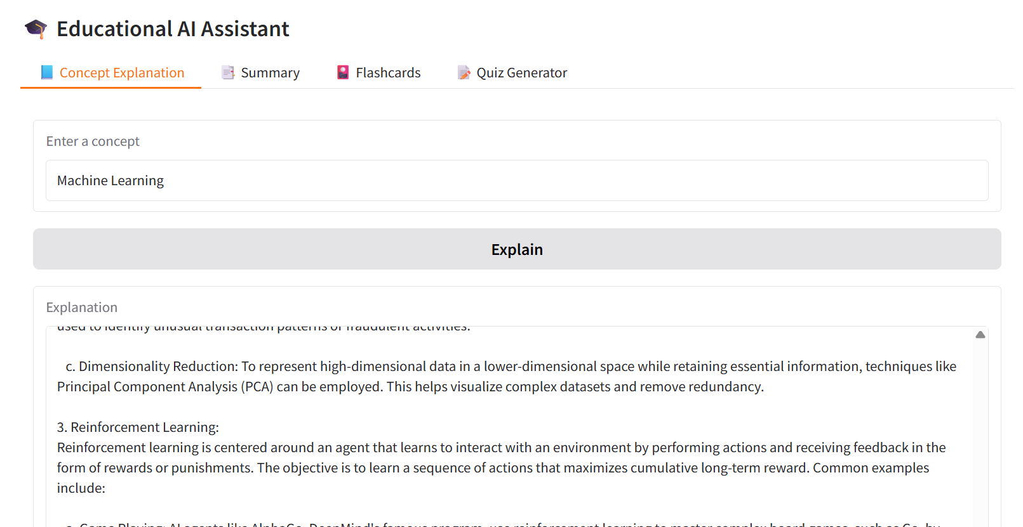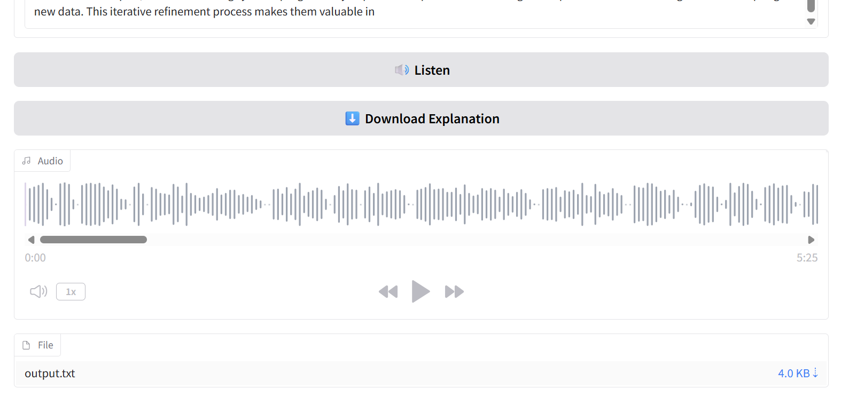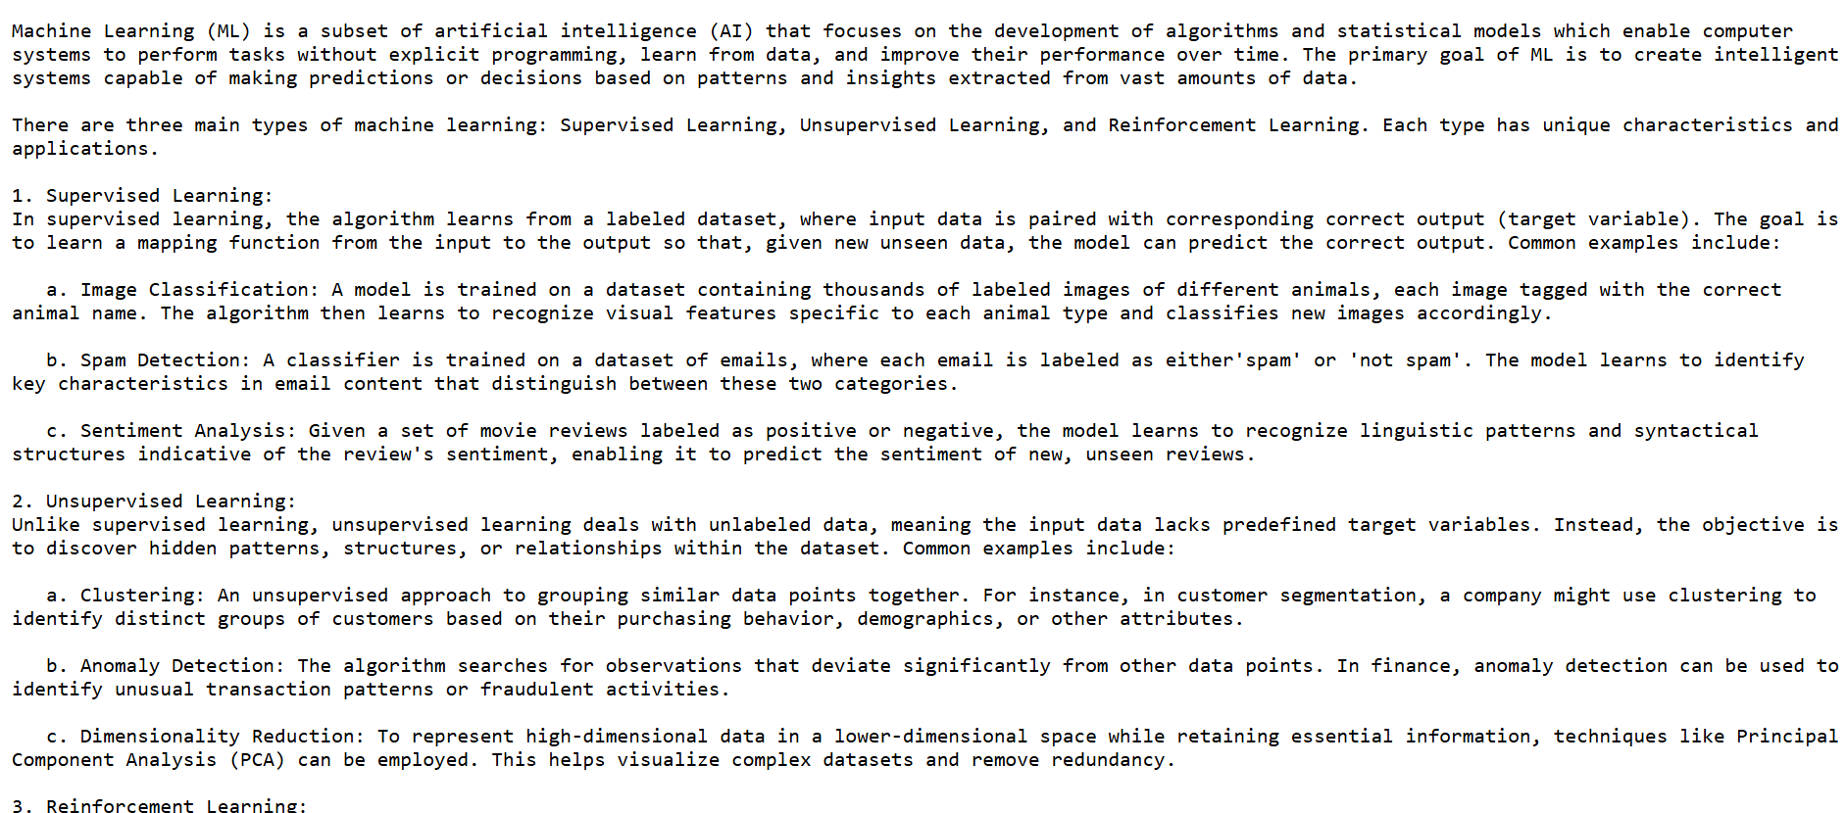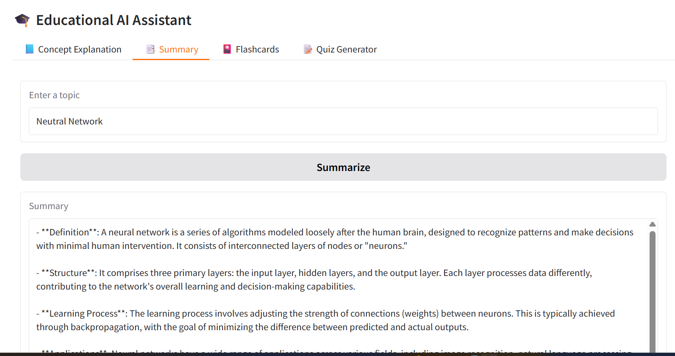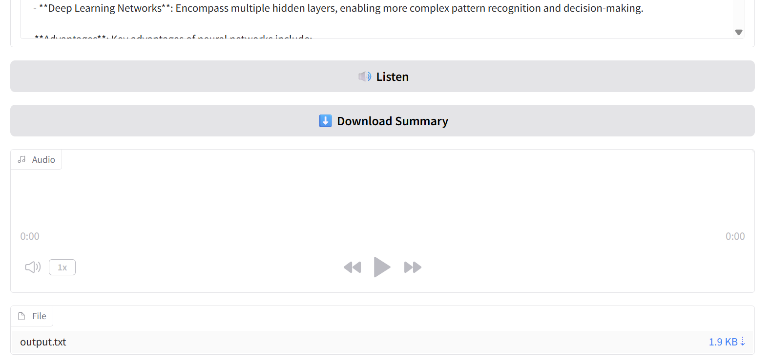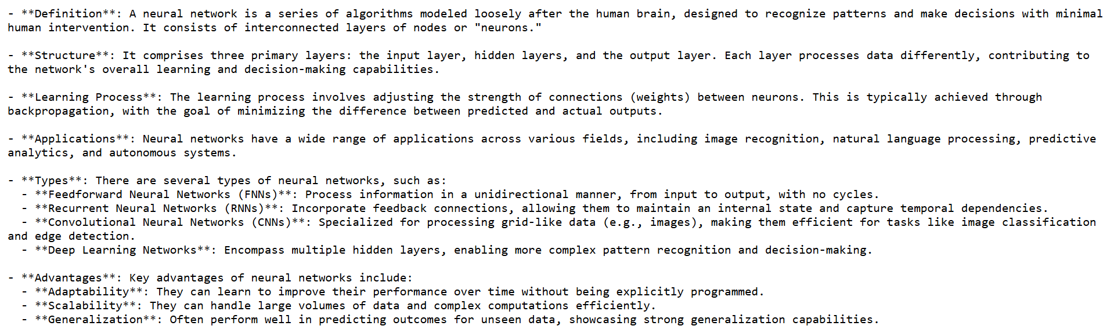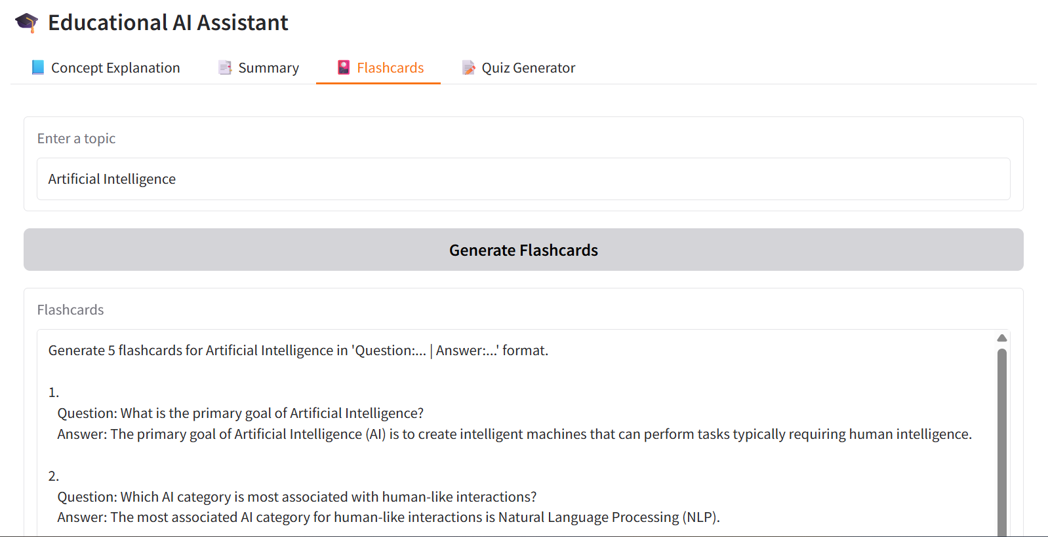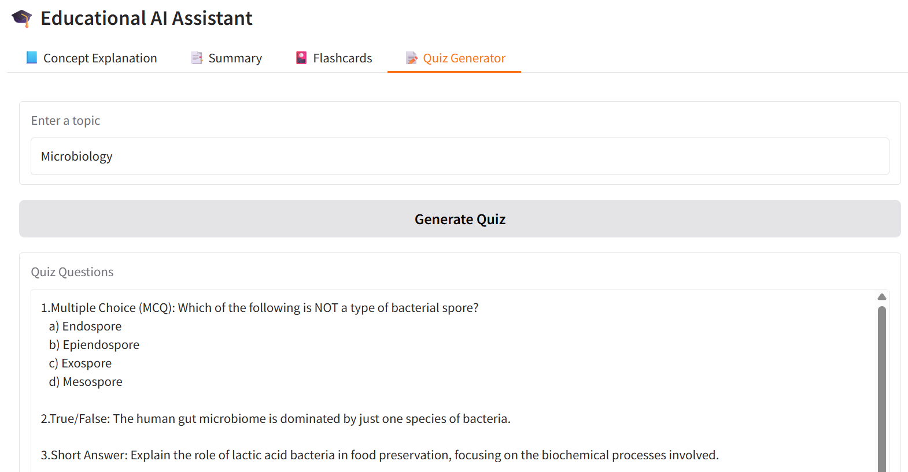

Known Issues
• Requires stable internet for model downloads.
Future Enhancements
• Add subject-specific quiz modules.
• Support multi-language explanations.
• Improve analytics with student progress tracking.

